**<Develop A Smart Attendance Capturing Mobile App >**

**A Minor Project Synopsis Submitted to**



**Rajiv Gandhi Proudyogiki Vishwavidyalaya, Bhopal**

**Towards Partial Fulfillment for the Award of**

**Bachelor of Technology**

**(Computer Science and Engineering)**

|  |  |  |  |
| --- | --- | --- | --- |
| **Under the Supervision of**  **Prof .** |  |  | **Submitted By Shubham Patel (0827CS201237)**  **Sarvesh lowanshi ( 0827CS201219)**  **Shivam chouhan ( 0827CS201228)**  **Vikash rawat ( 0827CS213D22)** |



**Department of Computer Science and Engineering**

**Acropolis Institute of Technology & Research, Indore**

**July-Dec 2022**

1. **Abstract**

Employee attendance tracking is a vital issue in order to monitor employee’ performance in the company as well as in their way of working their performance. It becomes a key concern because the company authority maintains a rule that one employee can only work in company if his/her attendance is higher or equal to several percentage otherwise not. The traditional attendance system needs employee’s to physically sign the attendance sheet each time for the attendance of each shift. This is unnecessarily time-consuming to notice and mark employee name on the attendance sheet. This also happens that some employee may accidentally or willingly mark the employee's name like as proxy and that employee is on holiday on the particular day. The hard copy of attendance sheet may get lost. Using Smartphone like as Android Technology the company leader or a manager will be able to take attendance easily by our designed mobile application and save the attendance in the phone as well as in server and can check percentage and also can print as hard copy. Using the stored information, this system is able to mark attendance, marking intruders’ entry, attendance percentage calculations, send emails, and send SMS to the employee to keep them updated about their attendance at the company.

# 2. Introduction of the Project (1 paragraph)

In current scenario, marking attendance in the company is the essential tasks of the record handlers. The management and maintenance of employee information is a key task for any company. it is not easy to manage the details and attendance of all the employees in paper. so, for overcome this problem we can design a proper software for attendance. Later, this task is carried out by the desktop applications. The desktop application is a standalone application installed in the particular desktop or laptop and the tasks can be performed only with that particular desktop system.

Another method for attendance entry is web-based application. In this method, the attendance and their performance details are uploaded in a server through internet and the users such as employee, company manager, company leader can view the performance and attendance through browsers with internet using any one of the devices such as desktop, laptop, and hand-held mobile devices. This system is active only when the internet is on since the data are not been updated with the local database.

These limitations of the traditional systems are overcome by the mobile applications. The mobile application allows the users to install this application in their mobile devices. The user can update the employee attendance details in the local mobile database by connecting their mobile devices with the server which keep the attendance details through internet. Hence, the updated attendance details can be viewed even offline. In order to reduce the manual work and to achieve more efficiency in managing the student information, a mobile application use to manage the employee attendance more easily and effectively. The proposed application can store employee information to the server database and it can be retrieved by the mobile phone and save that information in their local mobile database. Through this system, manager can easily record the employee attendance and can generate the reports.

# 3. Objective (100 words)

Some of the objectives of attendance taking are: **To know the whereabouts of every employee for safety and other reasons**. To determine the districts average daily attendance for state aid reimbursement. Attendance management system **keeps track of daily attendance, working hours, breaks, login, and logout time**. It prevents staff's time theft. An attendance management system integrates all attendance devices such as smart cards, biometric, and facial recognition devices in real-time.

So, by designing the proper attendance capturing mobile app, it is easy to maintain. And it is faster process. It works by detecting the face or by the help of QR Coad, fingerprint etc. So, it is very useful software not only for company purpose but also for college and many other places also

**4. Scope (100 words)**

-Provides facility for the automated attendance of students.

Uses live face recognition to recognize each individual and mark their attendance automatically.

-Utilizes video and image processing to provide inputs to the system.

Facility of marking manual attendance.

Notification via email if there is a lack of attendance.

# 5. Study of Existing System (200 words)

1. Fingerprint Based recognition system:

In the Fingerprint based existing attendance system, a portable fingerprint device need to be configured with the students fingerprint earlier. Later either during the lecture hours or before, the student needs to record the fingerprint on the configured device to ensure their attendance for the day. The problem with this approach is that during the lecture time it may distract of the students.

1. RFID (Radio Frequency Identification) Based recognition system:

In the RFID based existing system, the student needs to carry a Radio Frequency Identity Card with them and place the ID on the card reader to record their presence for the day. The system is capable of to connect to RS232 and record the attendance to the saved database. There are possibilities for the fraudulent access may occur. Some are students may make use of other students ID to ensure their presence when the particular student is absent or they even try to misuse it sometimes.

3. Iris Based Recognition System:

In the Iris based student attendance system, the student will scan the Iris of the student. Retinal scanning is a different, ocular-based biometric technology that uses the unique patterns on a person's retina blood vessels and is often confused with iris recognition. Iris recognition uses video camera technology with subtle near infrared illumination to acquire V the detail-rich, intricate structures of the iris which are visible externally. Digital templates encoded from these patterns by mathematical and statistical algorithms allow the identification of an individual or someone pretending to be that individual.[1] Databases of enrolled templates are searched by matcher engines at speeds measured in the millions of templates per second per (single core) CPU, and with remarkably low false match rates. needs to stand in front of a camera, so that the camera detect the face.

4. Face Based Recognition System:

The facial recognition technology can be used in recording the attendance through a high-resolution digital camera that detects and recognizes the faces of the students and the machine compares the recognized face with students’ face images stored in the database. Once the face of the student is matched with the stored image, then the attendance is marked in attendance database for further calculation. If the captured image doesn't match with the students' face present in the database, then this image is stored as a new image onto the database. In this system, there are possibilities for the camera to not to capture the image properly or it may miss some of the students from capturing.

**6. Project description.**

In this project we will develop a mobile app, with the help of this app we will take an attendance by capturing face eye or by finger prints of a user this is very helpful for the big companies and other crowd places this is also a time saving app, and easy to manage or store we cannot store the pages, files etc. for further requirement.

And we will determine the name, position, designation, age, mobile number, address, and all other details about the user by capturing the face of by fingerprint. we will also see the entry end exit time of an employee

We also use this app with or without wearing cap, helmet, etc. there is 95% accuracy in this and is very useful for all .

And ER diagram for above project is given below

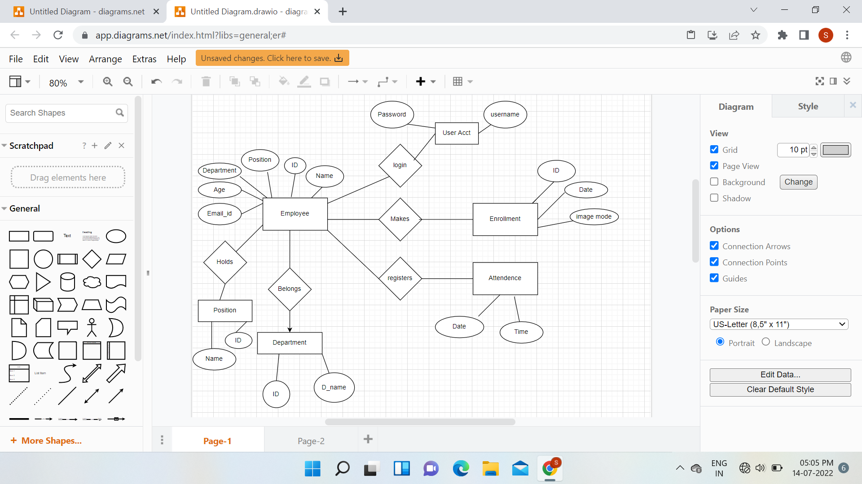

**7. Methodology/Planning of the Project work**

Our methodology we used to gather ideas To determine the best time and attendance systems , we started by listing all of the vendors that have a good reputation online ( i.e. , services that were favorably and consistently reviewed by other websites ). Then, we interviewed small business owners to discover new ones to add to our list .

We ultimately settled on 11 time and attendance systems to consider as best picks. They were: Acro time from Acro print, Clock VIEW from Acumen, Kronos ' Workforce Ready, status time from nettime solutions, Time Attend from Replicon, Time Click from Hawkeye Technology, Time Force from Infinisource, Time Star from Insperity, TSheets, Attend from Processing Point and Web timeclock .

Next, we researched each provider by investigating its services, watching tutorials and how to videos, trying out the system when possible, and reading user comments. We also considered the pricing that was listed on these services ' websites. In all, we analyzed each service based on the following factors:

* Cost
* Time-tracking capabilities
* Accrual options
* Overall monitoring
* Scheduling capabilities
* Available reports
* Ease of use
* Customer service
* Integration options
* Mobile access

**8. Expected Outcome (100-150 words)**

Mobile application will capture basic details of employees like Photograph (headshot), Name, Designation, Employee Number, Gender, Office Address, etc.

It should recognize the employee by face while capturing the attendance (entry) through face recognition and enter the relevant details including entry time in the system after successful face recognition. Similarly, while exiting the office premises, employee will be recognized using his/her face and exit time will be entered in the system.

The app should successfully work for any specific employees with or without wearing spectacles, cap or industrial helmet. This also notes down the time of arrival thus can acquire information about people coming in late after a specified time.

# 9. Resources and Limitations (150 words)

combines elements of the system planning and systems analysis phases of the Systems Development Life Cycle (SDLC) Users, managers, and IT staff members discuss and agree on business needs, project scope, constraints, and system requirements. It ends when the team agrees on the key issues and obtains management authorization to continue. The main method used in gathering data for this system was online interview.

Personnel that were interviewed include:

. Assistant head of ICT department Some employees

. Network Administrator

**FUNCTIONAL REQUIREMENTS**

⚫ System must capture faces

System must store faces in a DB attached to the employee's ID System must recognize the employee to enable attendance marking

**NON-FUNCTIONAL REQUIREMENTS**

System shall be error-free

⚫ System shall operate in real-time

⚫ System should prevent data manipulation

⚫ System should have a maximum uptime

HARDWARE REQUIREMENTS

⚫ Camera Computer System Screen.

**10. Conclusion (100-150 words)**

Automated attendance systems are more efficient than manual systems as it prevents employees from falsifying entireties’

**RECOMMENDATION**

For the purpose of ICT growth that will lead to a rich , efficient , and result driven mode of attendance in NIPLC , we recommend that the face recognition algorithm should be used in order to enhance the e - attendance system .

**PERSONAL EXPERIENCE**

The project really helped to sharpen our programming skills and SQL querying. It served as a tough challenge as writing algorithms for face detection and recognition was a huge step from our previous knowledge. It also gave an insight to our short comings and abilities.

**FUTURE RESEARCH DIRECTIONS**

The project is just a blueprint for implementing a full functional e - attendance system. After this blueprint, a thorough research should be carried out on this system, laying more emphasis on the impact it has on attendance and how it has enhanced company's employee – hour output the impact that this system has on the business sector should be studied and compared to that of the manual system.

Smartphone-based

Student Attendance System will

significantly develop the conventional procedure of student

attendance framework in a university/college/school

surroundings. Smartphone-based

Student Attendance System is

a computerized information accumulation technology, which

leads to more precise data entry. The stored student attendance

data are framed and investigate inevitably without any loss of

data, compared to a traditional recording method. A course

teacher can easily monitor the attendance of students which

may develop the excellence of instruction because the fewer

time required to collect and process data. Implementing the

system in educational environment helps the user to identify

attendance, proxy attendance, calculate percentage etc. SMS

and Email messages are sent via the system automatically to

inform parents so that they can get notified about their child’s

progress in the institution.

Smartphone-based

Student Attendance System will

significantly develop the conventional procedure of student

attendance framework in a university/college/school

surroundings. Smartphone-based

Student Attendance System is

a computerized information accumulation technology, which

leads to more precise data entry. The stored student attendance

data are framed and investigate inevitably without any loss of

data, compared to a traditional recording method. A course

teacher can easily monitor the attendance of students which

may develop the excellence of instruction because the fewer

time required to collect and process data. Implementing the

system in educational environment helps the user to identify

attendance, proxy attendance, calculate percentage etc. SMS

and Email messages are sent via the system automatically to

inform parents so that they can get notified about their child’s

progress in the institution.

# 11. References

http://www.projecttopics info Computer/Face Recognition in e-attendance [Accessed: August 2014]

The Code Project, "EMGU Multiple Face Recognition using PCA and Parallel

Optimization", 05 October 2011. Available http://www.codeproject.com/Articles/

261550/EMGU-Multiple-Face Recognition-using-PCA-and-Peral [Accessed:

September 2014] • https://developers.keylemon.com/welcome [Accessed: June 2014]... OpenCV API reference. Available: http://docs.opencv.org/modules/refiman.html

[Accessed: September 2014)

http://www.fhi.gov/about-us ciis fingerprints hiometrics biometric-center-of

excellence/modalities/facial-recognition Computer vision based employee.pdf

Available: https://www.google.com.ng/url?

sa-1&rct=j&q=&esrc=s&source=web&cd=2&cad=rja&uact=8&ved=0CCkQFjAB&url -http/3A2F2Edspace.bracu.ac. hd/bitstream/handlen 2E10361/2747% 2FComputer 2520vision 2520based%20cmployee.pdf

*63 Sequence=1&ei=CYWUusMazh7Aawy4HICOAFOCNEMIA FARO

yMtMgTG2w&sig=3u7 DZufmm4NYP+9JIMw

H. K. Ekene, J. Stall Kamp, H. Gao, M. Fischer. R. Stifelman, "FACE RECOGNITION FOR SMART INTERACATINONS", interact Research. Computer Science Department, University at Karlsruhe (TH).

⚫ Phillip lane Wilson, and Dr. John Fernandez, "FACIAL FEATURE DETECTION USING HAAR CLASSIFIERS", Texas A&M University. Viola, P. and M. Jones (2001), Rapid Object Detection Using a Boosted Cascade of Simple Features, in: Proc. IEEE Conf Computer Vision and Pattern Recognition. JA.C. Weaver, "Biometric authentication", Computer, 39(2), pp. 96-97 (2006).